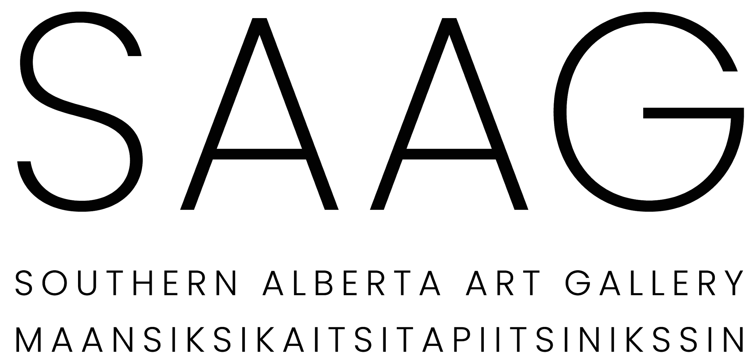

VOLUNTEER OPPORTUNITIES
The Southern Alberta Art Gallery Maansiksikaitsitapiitsinikssin is always looking for passionate and committed volunteers. We have a wide range of permanent and occasional opportunities available in a variety of roles.

RECURRING VOLUNTEER POSITIONS
Recurring volunteer positions are ideal for someone looking to volunteer for a few hours every week or on a consistent schedule with the Gallery.

Art Installation Assistant
Art Installation Assistants work with our Curator, Preparator, and installation team to remove existing exhibitions and install new ones. Tasks include painting and patching walls and can include art handling and packaging. This position is ideal for post-secondary students who want hands-on gallery experience or individuals with construction experience.

Art Library Assistant
Art Library Assistants will primarily assist in updating and maintaining our art library records. Tasks include re-shelving and organizing holdings, providing input on acquisitions, de-accessions, and cataloguing practices. Assisting in Bletcher Hour and future art library programming may also be involved. This position is perfect for someone who’s interested in art and/or library practices.

Gallery Tour Guides
If you have a passion for interacting with people and contemporary art, then this is the opportunity for you! Gallery Tour Guides will provide tours to the public during set times. Extensive training is provided so that Guides are knowledgeable about the artists and exhibitions and comfortable with questions and curiosity.

Programs & Event Support
In this role, you would support the Program & Events Coordinator with programs like the Articulations lecture series, the Bletcher Hour reading group, Crafternoons, and various workshops. Tasks include setting up equipment, snacks, etc., as well as assisting in and contributing to the facilitation of artist talks, lectures, and more.

Publication and Book Making Assistant
Tiny Press is a handmade bookbinding studio within the Gallery. Tiny Press prints and binds books one-at-a-time, collaborating with artists, writers, and designers from Southern Alberta and abroad. Publication Assistants would assist with Tiny Press workshops, the printing and binding of publications, and keeping the printing studio clean and organized. Extensive training is provided for this position.

SPECIAL EVENT OPPORTUNITIES
Every year the Gallery hosts two major fundraising events: Art Auction (April/May) and SAAG Social (November) as well as quarterly exhibition openings and a variety of other events throughout the year. We are always looking for volunteers to assist with these large events in the following roles:

Bartender
Bartending opportunities are a great way to enjoy the many social events at the Gallery from exhibition openings to special events. Volunteers assist with setting up snack areas, serving at the bar, and cleaning up after the event. If you’re social, personable, and energetic, then this is the position for you! ProServe certification is mandatory.

Gallery Attendants
Gallery Attendants assist with watching over the gallery spaces, clean up and take down, and much more. This is a great opportunity to engage with local, national, and international artists, as well as Lethbridge’s art community.

For more information, contact volunteer@saag.ca

